MatchMe  
User Manual

short line

RMIT University  
COSC2408: Programming Project 1

Table of Contents

**1. Sign up** **2**

**2. Sign in/Sign out** **7**

**3. Edit profile** **8**

**4. Change account settings** **10**

**5. View matches** **12**

**6. Like/Unlike user** **13**

**7. View Likes/Liked by** **14**

**8. Admin: delete user** **17**

**9. Admin: search users** **18**

# 1. Sign up

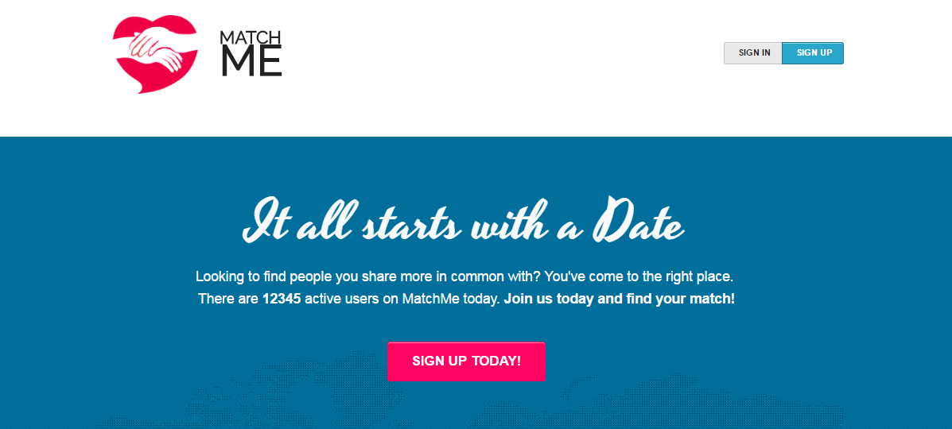

1. Navigate to: <http://matchmeplease.herokuapp.com>

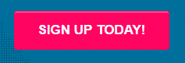Signup3.PNG

1. Click the signup button on header or the ‘sign up today’ on the page.

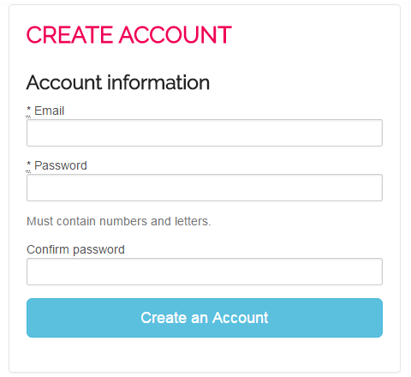

1. On the signup page, enter a valid email address
2. Enter a password containing both letters and numbers.
3. Confirm password chosen by typing it again into the Confirm Password field
4. Register the account by clicking the ‘Create an Account’ button
   1. If validation fails, ‘Create Account’ page will instead re-render with error messages.
   2. If successful, you will be redirected to the ‘Create Profile’ page:

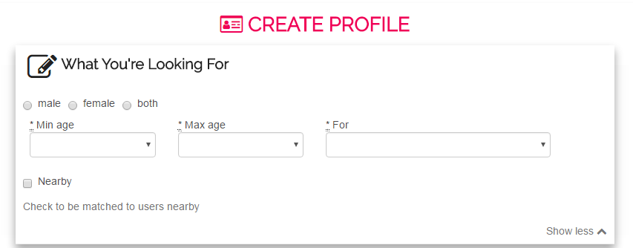

7. Fill out the first form ‘What You’re Looking for’

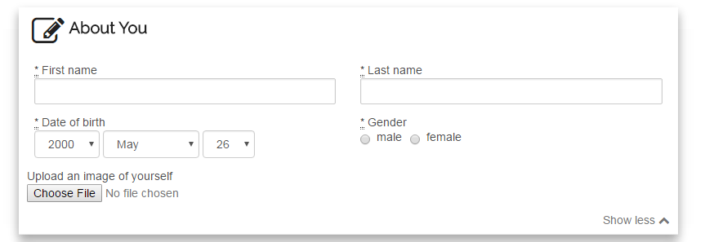

8. Fill out the second form ‘About You’. A profile picture may also be uploaded, but this is optional.

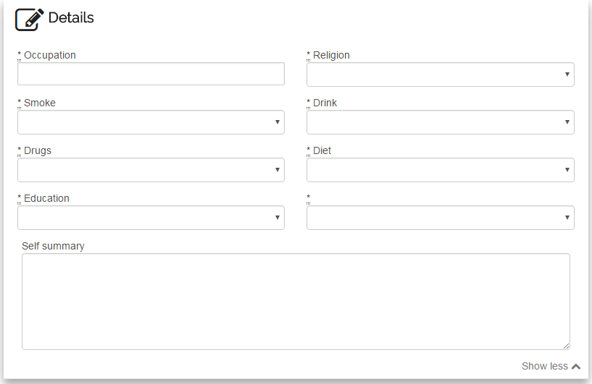

9. Fill out the next form ‘Details’

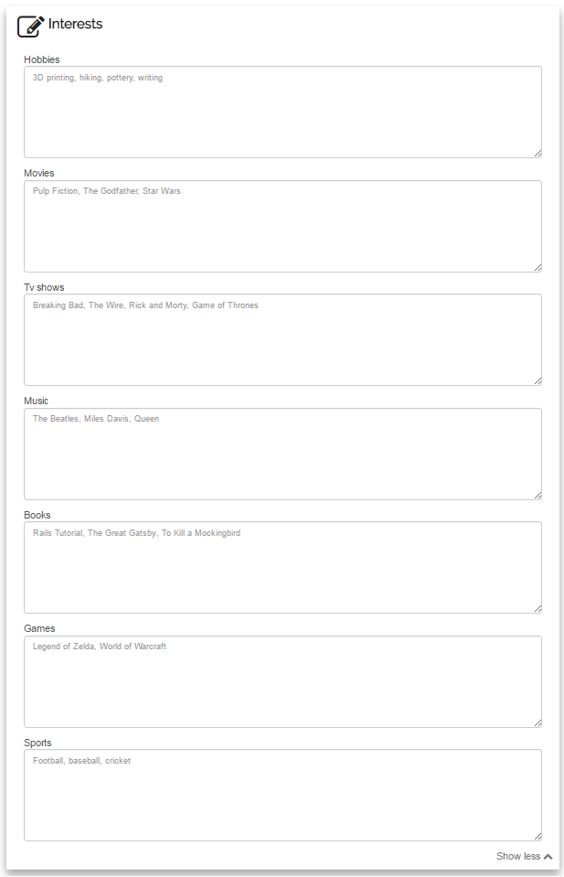

10. Fill out the next form ‘Interests’. Note: while these fields are optional, filling them out will greatly increase your chance of being accurately matched with other users.

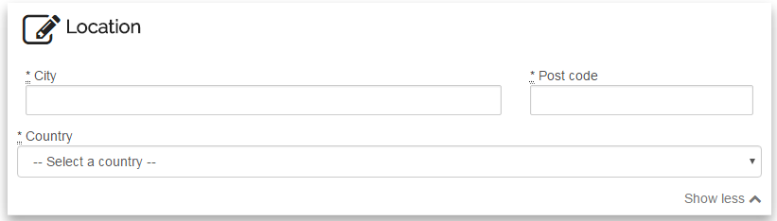

11. Fill out the last form ‘Location’

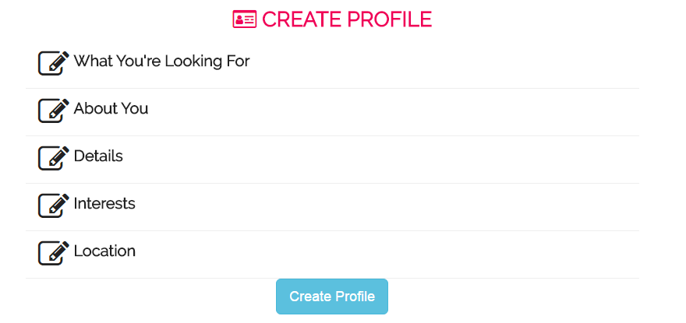

12. After filling out required fields, click ‘Create Profile’ button

1. If successful, user will be redirected to the user profile page
2. If validation fails, page will re-render with error messages.

# 2. Sign in/Sign out

1. Navigate to MatchMe
2. Click the ‘Sign In’ button in the page header

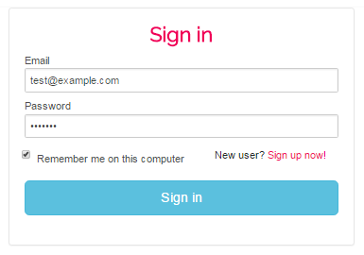

1. Fill out the Email Address field
2. Fill out the Password field
3. Tick the “Remember Me” checkbox if you want your session to be remembered, otherwise leave it blank.
4. Click on “Sign in” button
   1. If successful, user will be redirected to the user profile page (if logging in as a normal user) or users index (if logging in as an admin)
   2. If input validation fails, login page will instead re-render with relevant error messages
5. After logging in, user can logout by clicking the ‘Account’ menu and clicking ‘Log out’.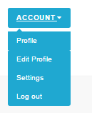

# 3. Edit profile

1. Navigate to MatchMe
2. Sign in as a non-admin user

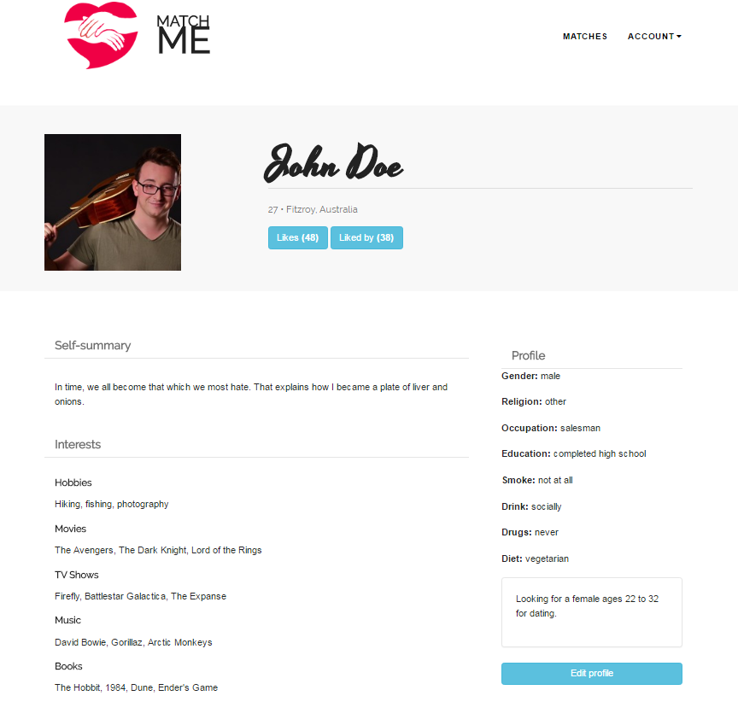



1. User can find the “Edit profile” link on the bottom-right of their profile page or in the ‘Account’ drop down menu located in header. Click this link.

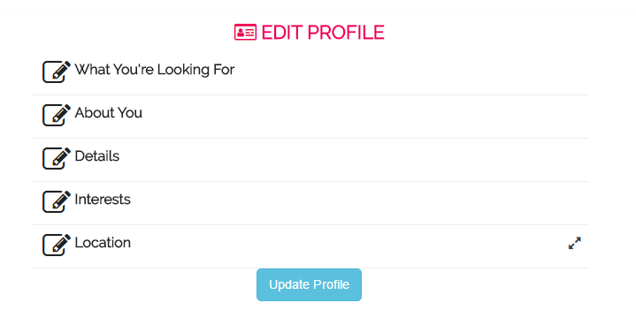

1. User will be redirected to edit profile page
2. Fill in fields that you wish to change
3. After finish all changes click ‘Update Profile’ button
4. If successful, user will be redirected to the user profile page
5. If validation fails, user will receive the error message

# 4. Change account settings

1. Navigate to the website
2. Sign in



1. Click the “Settings” link in the “Account” menu on the top-right of the page

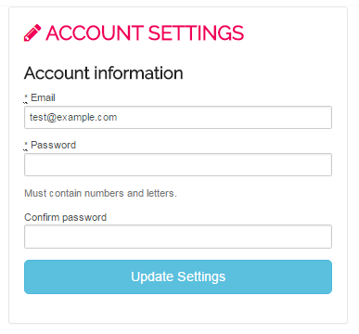

1. To change email address, enter new email address in “Email” field
2. To change password, enter new password in “Password” field and again in “Confirm password” field
3. Click “Update Settings” button
   1. If successful, user will be redirected to the user profile page (if logged in as non-admin) or users index (if logged in as admin)
   2. If input validation fails, account information will not be updated and instead the page will re-render with error messages.

# 5. View matches

1. Navigate to MatchMe
2. Sign in as a non-admin user

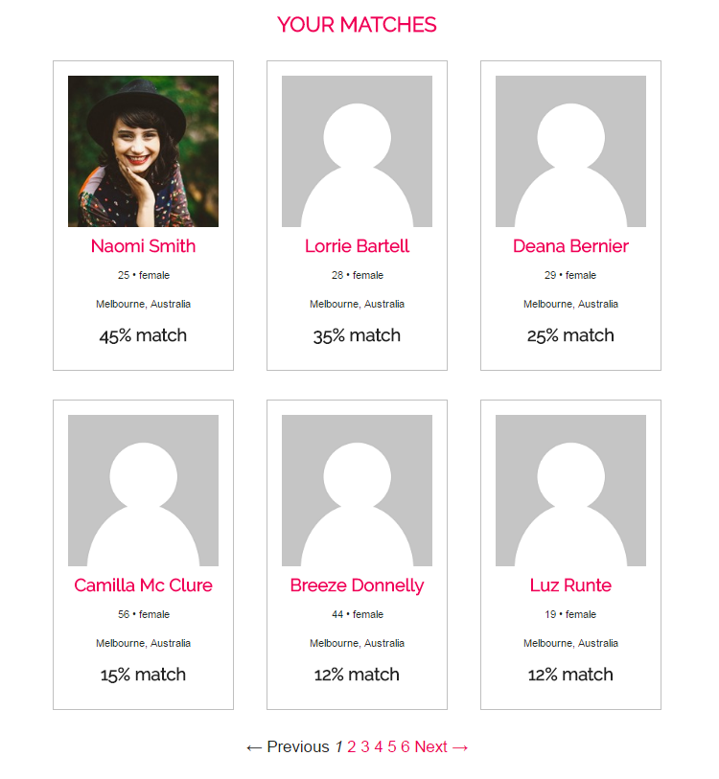

1. User can view their matches by clicking the “Matches” lick in the page header

# 6. Like/Unlike user

1. Navigate to MatchMe
2. Sign in as a non-admin user
3. Click “matches” button and click on a user to view their profile

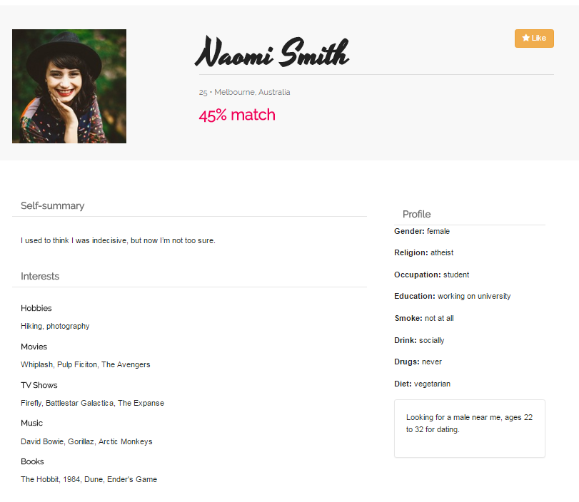

1. To like the user, click the “Like” button (found to the right of their name)

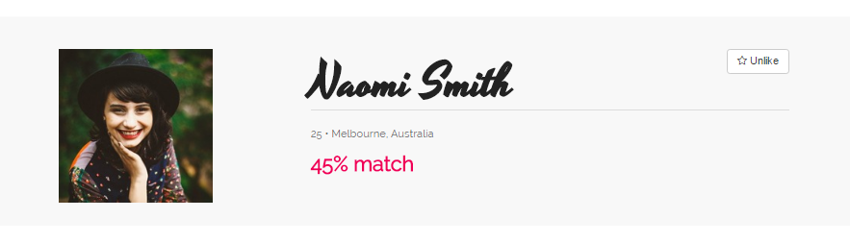

1. To unlike the user, click the “Unlike” button

# 7. View Likes/Liked by

1. Navigate to Matchme
2. Sign in as a non-admin user

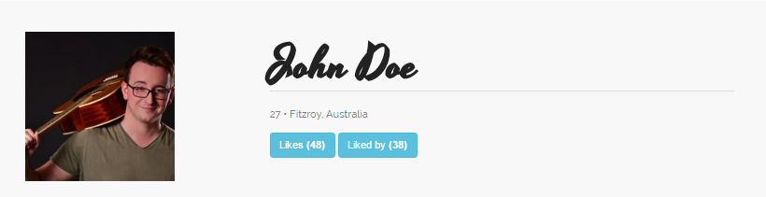

1. On your profile “Likes” and “Liked by” buttons should appear below your age and location
2. To view users you have liked, click “Likes” button

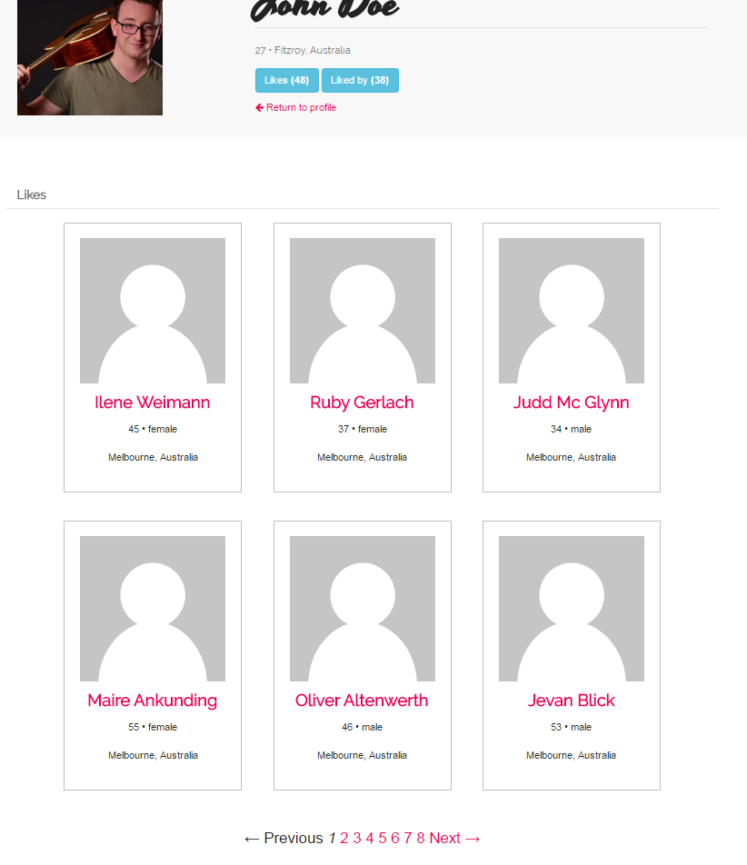

1. To view users who have liked you, click “Liked by” button

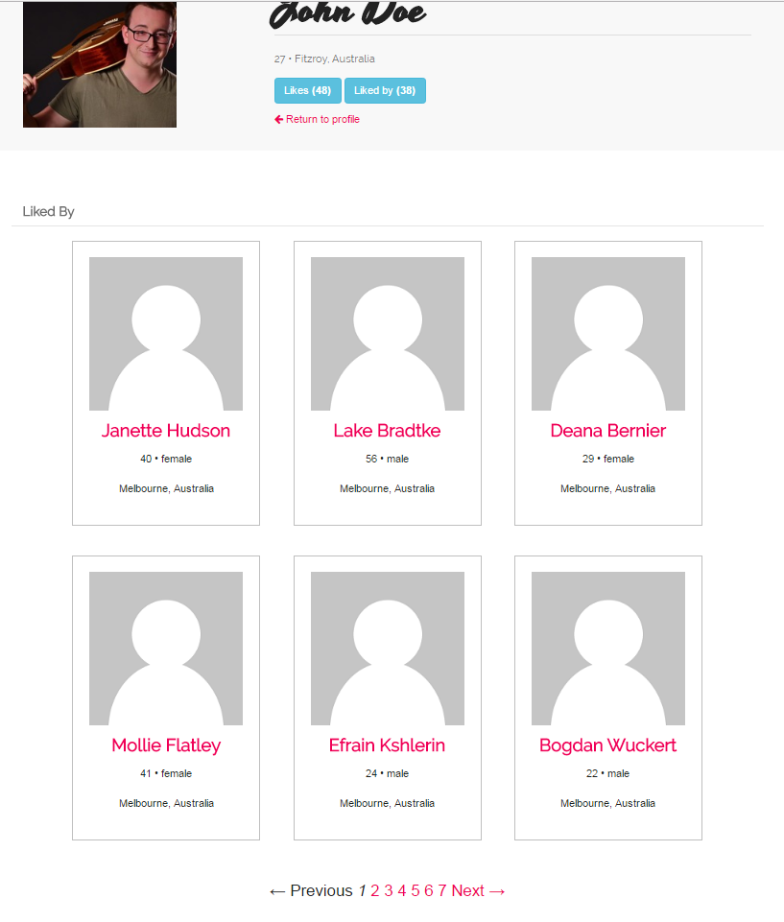

# 8. Admin: delete user

1. Navigate to MatchMe
2. Sign in as an admin. You will be re-directed to the Users Index page, which displays a list of all users.
3. On users index, choose a user to delete and click link that says “delete user” located below their location information

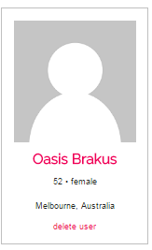

1. Alternatively, you may also delete a user from their profile by clicking the “Delete” button located to the right of their name.

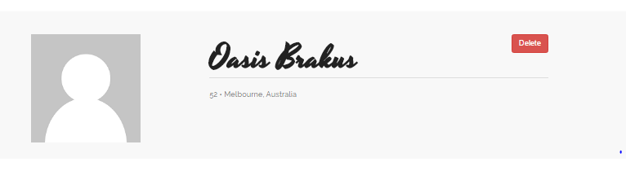

1. When the confirmation message pops up, click “Yes” to confirm.

# 9. Admin: search users

1. Navigate to MatchMe
2. Sign in as an admin. You will be redirected to the Users Index page.

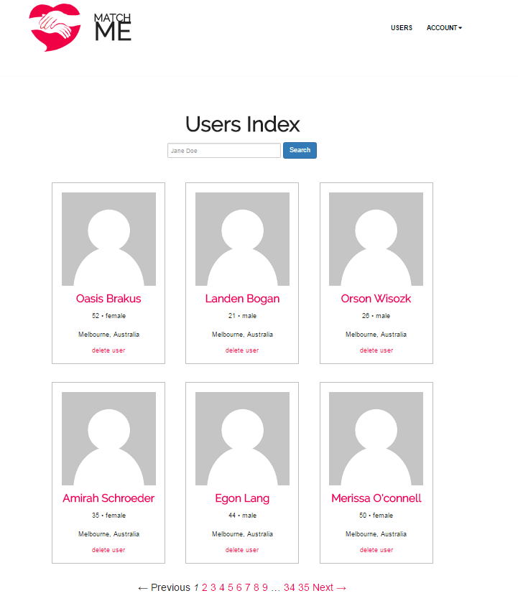

1. To search for a user, enter their name into the search field. Can be their first or last name, or even part of their name.

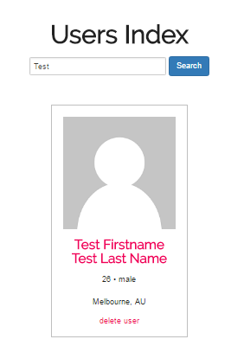

1. Click “Search” button. Page will render with search results (if any match).